CS-003 Mold Design & Manufacturing
Doc ID | CS-003
Title | Mold Design & Manufacturing
Revision | E
Status | Draft, pending Lead signature
Effective date | 2026-10-10
Supersedes | Tribal mold-design practice; consolidates SN4 Mold Manufacturing Problems and Solutions + Mold Design Documentation

Approvals
Role | Name | Date
Author | Simon Starbuck (drafted with Claude, SN6 Resources) | 2026-07-12
Reviewer | simon (reviewer agent) | 2026-10-10
Approver (Composites Lead)

Revision history
Rev | Date | Author | Description of change
A | 2026-07-12 | Claude | Initial issue
B | 2026-07-28 | Claude | Language pass: fewer em dashes for rhythm variety, no content change.
C | 2026-08-03 | Claude | Glue-up marking made explicit in §7.3: oil-based paint marker on two adjacent side faces, not a Sharpie, which the process's own IPA wipe dissolves (CS-001 §7.4).
D | 2026-08-28 | Claude | Engineering pass (CS-000 Rev C conventions). Figure 1 dimensions the §7.1 design rules on a mold cross-section, which is the form the §7.2 reviewer actually checks them in. No rule changed.
E | 2026-10-10 | Claude (doc overhaul, requested by Simon Starbuck) | The app's mold workflow written in, because the standard predated it: stack planning, the Fusion add-in, the cut list, mold stages and the mold record (§4, §5, §7.1 steps 8-10, §7.3, §7.4, §9). Rule changes: the design review now gates cutting blanks; split molds allowed for overhangs; a split waiver with a depth check; board grades never swapped silently; re-plans by a lead only; datum cut plans should be attached; vacuum, not compressed air, before gluing; blanks cut on a saw (the ShopSabre may be used); mold ID added to the glue-up marking (Simon, 2026-10-10); Ure-Bond PPE from the TB and SDS (Simon, 2026-10-10). Ure-Bond 90 hazards corrected to the SDS and its mix, pot life, clamp and cure numbers put in the steps from the TB. Title field matches the H1; references added; emphasis bold dropped. Glue-up records go on Glue and machine mold on a wet-layup run. R6 (Rohacell) dropped; new references are R7-R10. Round 6 fact-check: 45 lb/ft³ added to the board grades (R-003-31); each blank marked with its mold ID or plan name and layer tag before it leaves the saw (§7.3 step 4, R-001-17 and R-003-25, Simon, 2026-10-10), and the Mark cut dialog split into one action per step, so §7.3 steps 5 on are renumbered; Ure-Bond gloves corrected to what the SDS names, with nitrile as the team's glove until those are stocked, and the respirator required where the room cannot be ventilated (R-003-02, Simon's PPE answer); the app's Self-review warning, the lead's Sign without it, the planner's Boards modes and the + New run mold fill written in; the TB's 30 lb/ft³ adhesive rating noted. Anyone with asthma or a past isocyanate reaction shall not mix Ure-Bond 90 (SDS H334). Ure-Bond on 45 and 60 lb board and a training gate for gluing are held for Simon. Register R-003-01..25, R-003-31.

1. Purpose
A mold error you find after machining burns our three scarcest things at once: tooling board, machine time, and calendar. The SN5 clamshell CAD error (raised middle section, Feb 2026) forced a re-glue and re-machine and killed a week of slots in our tightest month (PP-03). This doc collects our mold design rules and adds the one check that would have caught it: someone who didn't design the mold reviews it before any board gets glued or cut.

2. Scope
Female/male molds machined from polyurethane tooling board (30–60 lb/ft³) for infusion and wet layup, including split molds for parts with an overhang (§7.1 step 4). Appendix A covers 3D-printed compression (forged CF) molds. Hotwire foam molds: out of scope (own project doc until standardized).

3. References
Ref | Document | Where
R1 | Ure-Bond 90 technical bulletin + SDS | 03 Datasheets/URE_BOND_90_TB.pdf, 03 Datasheets/1386A_2-1386B_2.pdf
R2 | SN4 Mold Manufacturing Problems and Solutions (2025-10-12) | SN5 Composites/Documentation/SN4 Mold Manufacturing Problems and Solutions.docx
R3 | Mold Design Documentation (wing mold CAD process + videos) | SN5 Composites/Documentation/Mold Design/Mold Design Documentation.docx
R4 | PP-03 RCA | FEB-COMP-PP-001 (01 Pain Points and Improvements/src/pain-points.md)
R5 | CS-005 (machining), CS-004 (sealing) | this series
R7 | App README: "Molds" and "The cut list, on paper" | 06 Composites App/app/README.md
R8 | FEBPlanStock Fusion add-in README | 10 Fusion Add-in/FEBPlanStock/README.md
R9 | SN5 Tooling Board Adhesives (adhesive survey, 2025-10-12) | SN5 Composites/Documentation/SN5 Tooling Board Adhesives.docx
R10 | Precision Board PBLT-30 and PBLT-60 TDS, PBLT SDS (Coastal Enterprises). Confirm PBLT, not PBHT, against a board label | 03 Datasheets/PRECISIONBOARD-TDS-PBLT-30.pdf, 03 Datasheets/PRECISIONBOARD-TDS-PBLT-60.pdf, 03 Datasheets/PRECISIONBOARD-SDS-PBLT.pdf

Why Ure-Bond 90: SN4's board-stacking method (vacuum-bag with laminating resin) was slow and resin-hungry (R2). Ure-Bond 90 (R1) is a purpose-made rigid urethane adhesive: strong bond between boards, ~4 h clamp time, no bagging. Dowels + spot resin remain acceptable for very large stacks where adhesive cost bites.

4. Definitions
- Flange: flat margin around the part cavity for tacky tape, infusion lines, and trimming reference.
- Scribe line: machined V-groove marking the part trim boundary and datums.
- Stack (mold stock): tooling boards glued into a block thick enough for the mold.
- Max-Z: the machine's maximum cut depth; molds taller than max-Z must be split into sections with alignment datums, unless the split is waived (§7.1 step 6).
- Mold record: the mold's own record in the app, MOLD-SN6-###, on the Molds tab. It exists from the moment the stack is planned (§7.1 step 8) and is separate from any work order.
- Mold file: the mold's current stack plan, STK-SN6-###, shown under Mold file on the mold page. Older plans stay listed under Earlier and are marked Superseded.
- Mold stage: where a mold is in its life, set on the mold page. The track is Designed, Tooling cut, Board glued, Machined, Sealed, Ready for layup; Retired sits off the track (app/shop.js). Each step below names the stage it sets. A mold that will not be used again is retired, never deleted.
- Datum cut plan: the drawing of the reference cuts taken off a mold after a part comes out of it, attached on the mold page under Datum cut plans. Most molds never need one.

5. Equipment & Materials
Item | Spec / product | Source | Notes
Tooling board | PU, 30 lb/ft³ general / 45 lb/ft³ / 60 lb/ft³ fine-finish (the grades the app plans, app/stock.js) | Coastal Enterprises (sponsor); TDS and SDS R10 | 60 lb seals better (CS-004). No TDS on file for 45 lb, and PBLT is not listed at 45 (R10 PBLT-30 p1 lists 40 and 48): read the grade off the board label. On hand: Inventory → Boards, one record per sheet or offcut (BRD-SN6-###) with its shelf. When Boards is set to choose them for me, from stock (the default), the planner uses only boards recorded there
Board adhesive | Ure-Bond 90 | Smooth-On | R1; clamp 4 h. The TB rates it for board up to 30 lb/ft³; its use on 45 and 60 lb board is team practice, held for Simon (R-003-03)
Dowels | Hardwood/aluminum, ~10 mm | McMaster | Large stacks; alignment
Clamps | Bar clamps, even spread | RFS
CAD/CAM | Fusion 360 (team standard) |  | CAM review per CS-005
Stack planning from Fusion | FEBPlanStock add-in (R8) | Molds tab → Plan from Fusion (opens the download) | In Fusion: Utilities tab → FEB panel → Plan stock (§7.1 step 9). If the app says the add-in is out of date, reinstall it from Plan from Fusion on the Molds tab (app/fusion.js)

Board grades: grades shall not be swapped silently. Plan a mold at one grade, or give a range in the New mold dialog with Board density, min (lb/ft³) and Board density, max (lb/ft³). Inside that range any board may supply any blank, including two grades side by side in one layer. The densest board cut sets the feed for the whole stack (CS-005 §7.4); the app records it as the mold's Highest density cut when the boards are marked cut (app/stock.js).

6. Safety
- Tooling-board dust (gluing prep, any hand-shaping): abrasive and irritating, dust mask minimum, respirator + extraction for power sanding (CS-009 PPE table).
- Ure-Bond 90 (R1, SDS 03 Datasheets/1386A_2-1386B_2.pdf): two-part urethane. Part A contains MDI (methylene diphenyl diisocyanate, CAS 101-68-8, 15 to 35 %), an isocyanate (SDS §3). Part A causes skin and eye irritation, may cause an allergic skin reaction, is harmful if inhaled, may cause allergy or asthma symptoms if inhaled, may irritate the airways, is suspected of causing cancer and may damage the airways through repeated exposure (H315, H319, H317, H332, H334, H335, H351, H373; SDS 1386A §2). Part B is not classified (SDS 1386B §2). Mix and glue only with room-size ventilation, and never heat or spray it: the TB warns the vapors become significant when heated or sprayed (03 Datasheets/URE_BOND_90_TB.pdf). Wear safety glasses with side shields (SDS 1386A §8) and long sleeves (TB). Gloves: the SDS names liquid-tight butyl rubber, neoprene or PVC gloves (SDS 1386A §8) and the TB says rubber gloves; neither names nitrile. Until the shop stocks one of those, wear the shop's nitrile gloves (team practice). You should wear butyl, neoprene or PVC gloves; they are on the purchase list. If the room cannot be ventilated, wear the CS-009 respirator (SDS P284). Eyes: flush with water for 15 min and get medical attention (TB). Skin: remove with soap and water (TB). Clamped assemblies stay put for 4 h (TB).
- Past reaction or asthma: anyone with asthma or a past reaction to isocyanates shall not mix Ure-Bond 90, and tells a lead (SDS 1386A §2, H334). There is other work on a gluing night.
- Heavy stacks: two people to move anything over ~half a sheet; watch pinch points at clamping.

7. Procedure

7.1 Design rules (CAD)
- Build the mold body from the part surface per the R3 process (section curves → loft → mirror); keep the machining time target ≤ ~3 h per mold section where practical.
- Flanges: ≥75 mm flat margin beyond the part edge on all sides; tacky tape + spiral tubing + trim allowance need it (SN4 lesson: insufficient side stock, R2).
- Scribe lines: machine part-boundary scribes parallel to ribs/features plus two datum scribes; they must survive sealing (CS-004 §7.3 step 5).
- No overhangs. 3-axis machining only; check every face has positive draft from the machining direction. Target ≥2° draft on deep walls. A part with an overhang is made on a split mold: each piece has positive draft from its own machining direction, and the split line and its alignment features are designed in CAD.
- Foam support: no unsupported sections thinner than 15 mm; tooling board snaps (R3). Fillet internal corners ≥ the finishing-tool radius.
- Max-Z check: if mold height exceeds machine max-Z, split into sections in CAD with dowel/datum features designed in, not improvised at the machine (R2). The planner splits any stack over 6 in into sections automatically (app/slicer.js, 152.4 mm). Tick "Machined depth stays under 6in" in the mold dialog only when the design keeps the cutter within 6 in of a face it can reach (a shallow cavity in a tall blank, dowelled inserts, a face machined from both sides). The app records who ticked it and when, and shows the mold as split waived.
- Attachment/mounting points: where the part needs marked hole locations (seat lesson, Oct 2025 meeting notes), design small conical divots into the mold surface.
- Stack plan: plan the stack in the app before the §7.2 review.
- On the Molds tab press + Mold. For an existing mold, a lead presses Re-plan (or Plan the stack, on a mold with no plan yet).
- Start from an STL exported in millimetres with STL units set to millimetres (the app warns that a mismatch is a 25.4× mistake), from dimensions (X × Y × Z), or from the Fusion add-in (step 9).
- Plan one body at a time. A multi-body STL asks "Which body?" and plans the one you pick.
- With Boards set to choose them for me, from stock (the default), the planner picks thicknesses only from boards recorded in Inventory → Boards. I'll pick the thicknesses is not checked against the rack: use it only for boards you have in hand. Either way the planner splits any stack over 6 in (step 6) and creates the mold record at Designed, with the plan (STK-SN6-###) as its Mold file. Starting from nothing yet, just record the mold creates the mold at Designed with no Mold file; plan its stack before the §7.2 review.
- STL planning is marked beta in the app. Check the Stack drawing on the mold page (under the heading Stack, below Mold in stock) before anyone cuts, and plan from dimensions if it looks wrong.
- Re-plans are a lead's. The old plan stays under Earlier, marked Superseded. Cut and machine only from the current plan.
- Plan from Fusion: install the FEBPlanStock add-in from Molds → Plan from Fusion (R8). In Fusion, open the mold design and press Utilities tab → FEB panel → Plan stock. Select the Mold body, one body at a time. Select the Bottom face too if the mold is not modelled bottom-down (a split mold on its side). Set density in the app's mold dialog that opens in the palette, and press Plan. The blanks come back as see-through bodies in a component named after the plan (STK-SN6-###); use them as CAM stock. The add-in saves nothing to the document: save it yourself.
- Split molds: each piece of a split mold is its own mold record. Link every piece on the part page ("+ Link a mold…", then "+ Link another mold…"). A work order covers one mold, so the second piece gets its own run and its own §7.2 review. + New run fills in the part's first linked mold: on the second piece's run, set Mold ID in the run's Details to that piece's MOLD-SN6-###.
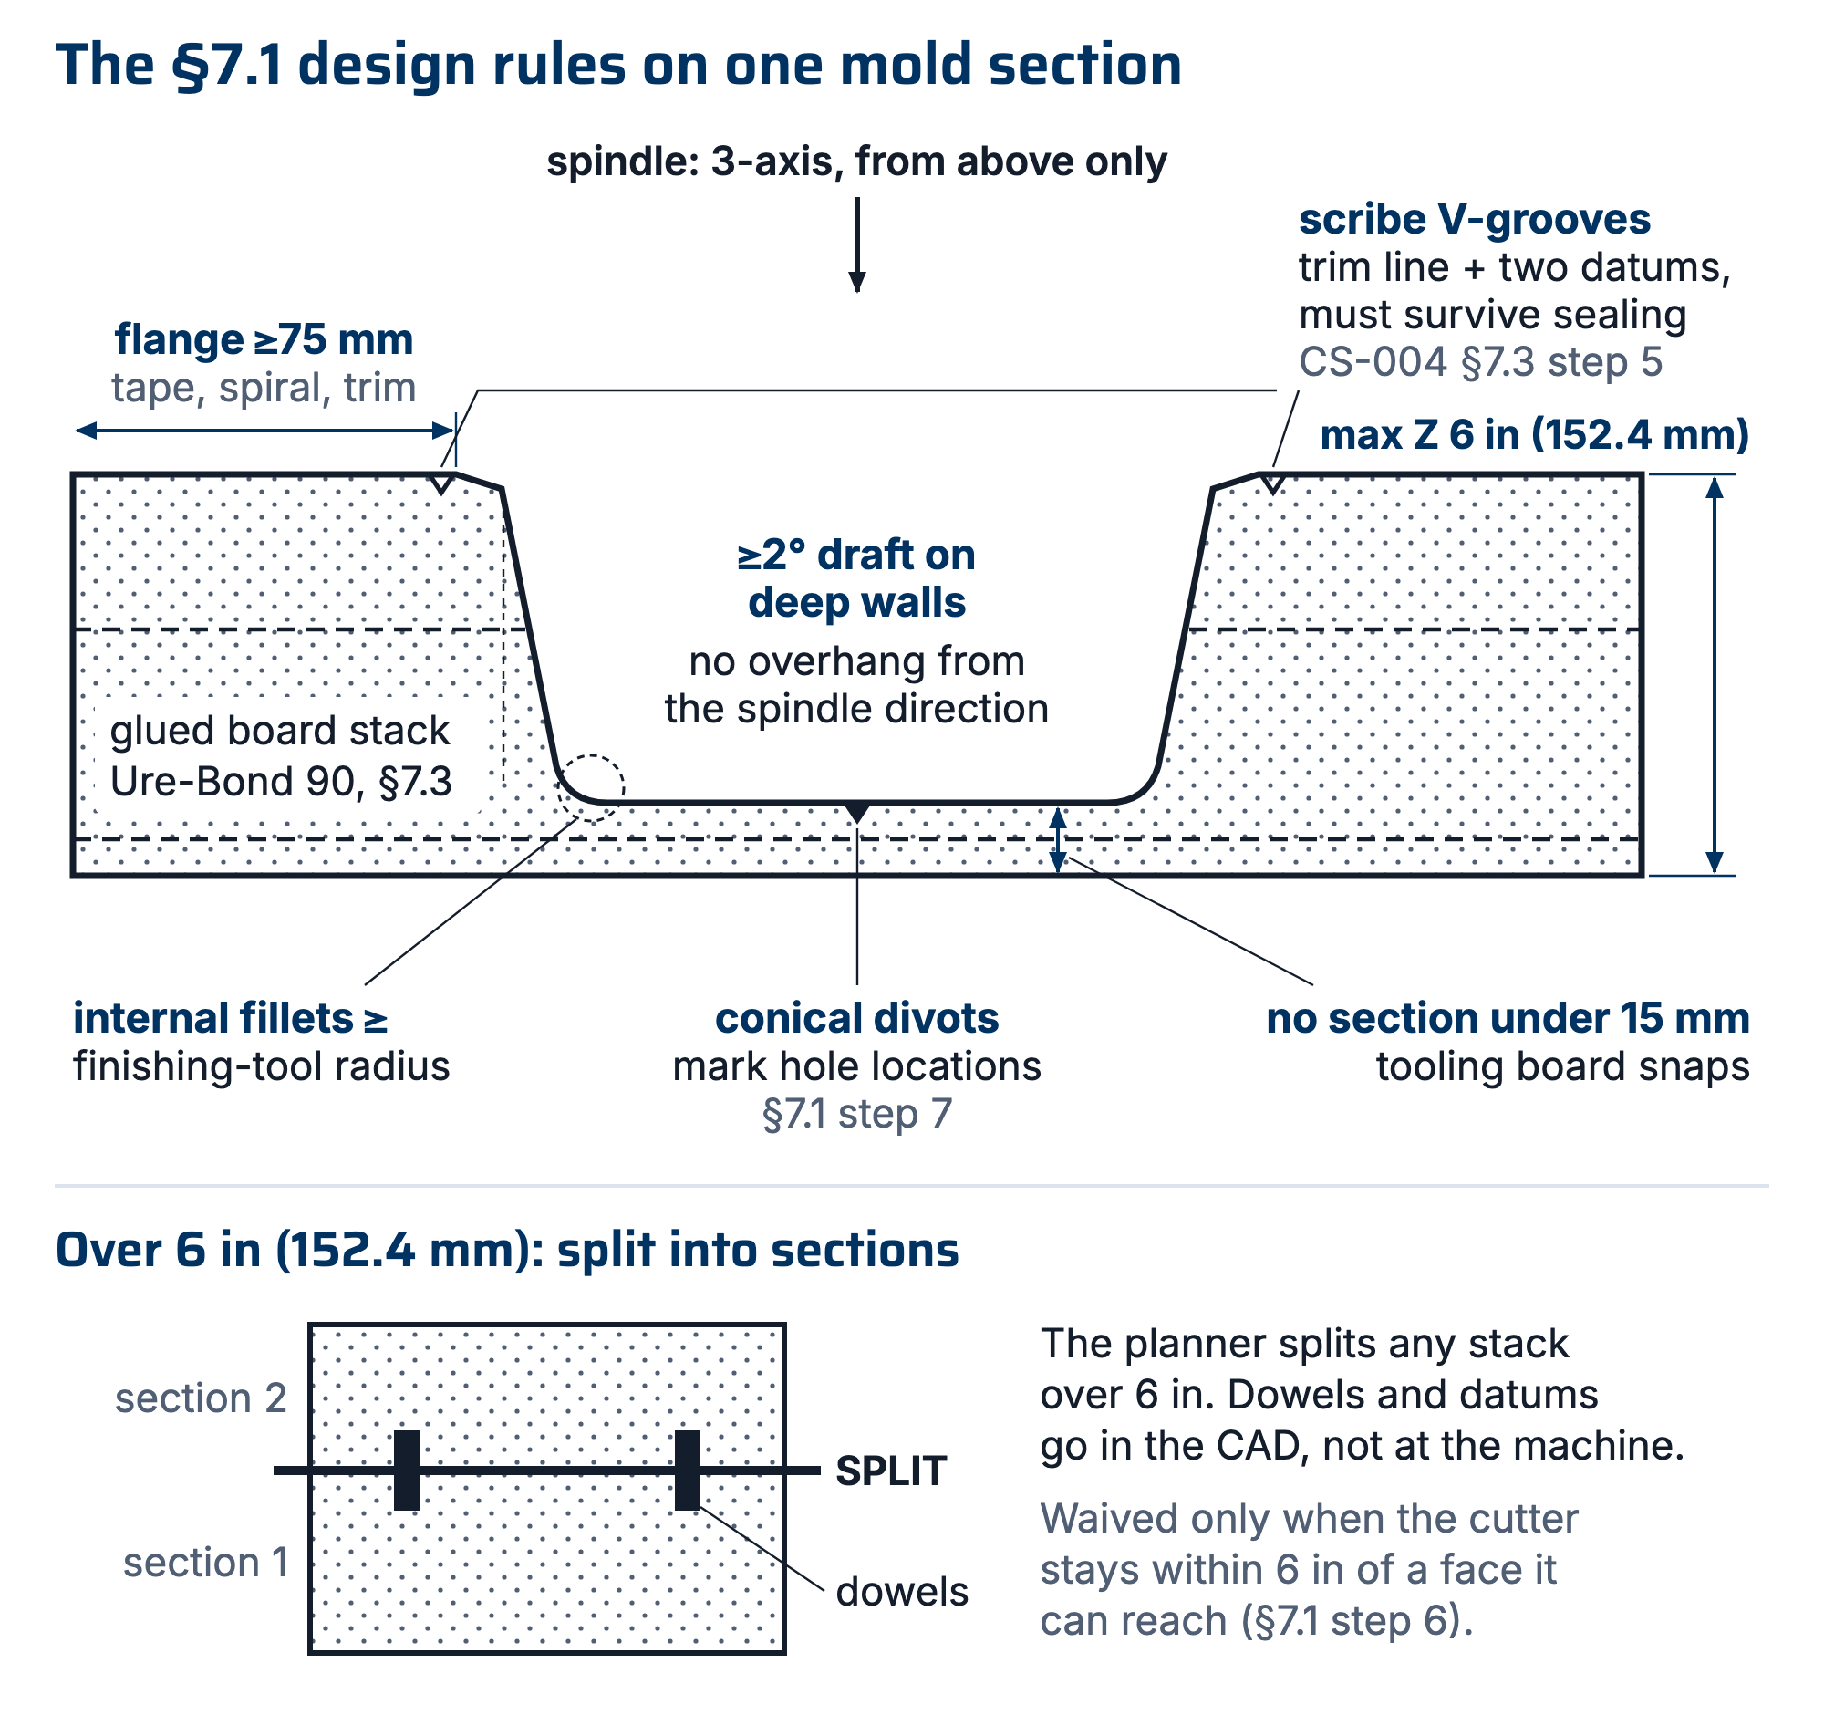
Figure 1. The §7.1 design rules dimensioned on a mold section: flange width, draft, minimum section, fillets, scribes, and the max-Z ceiling, all from the one spindle direction that exists.

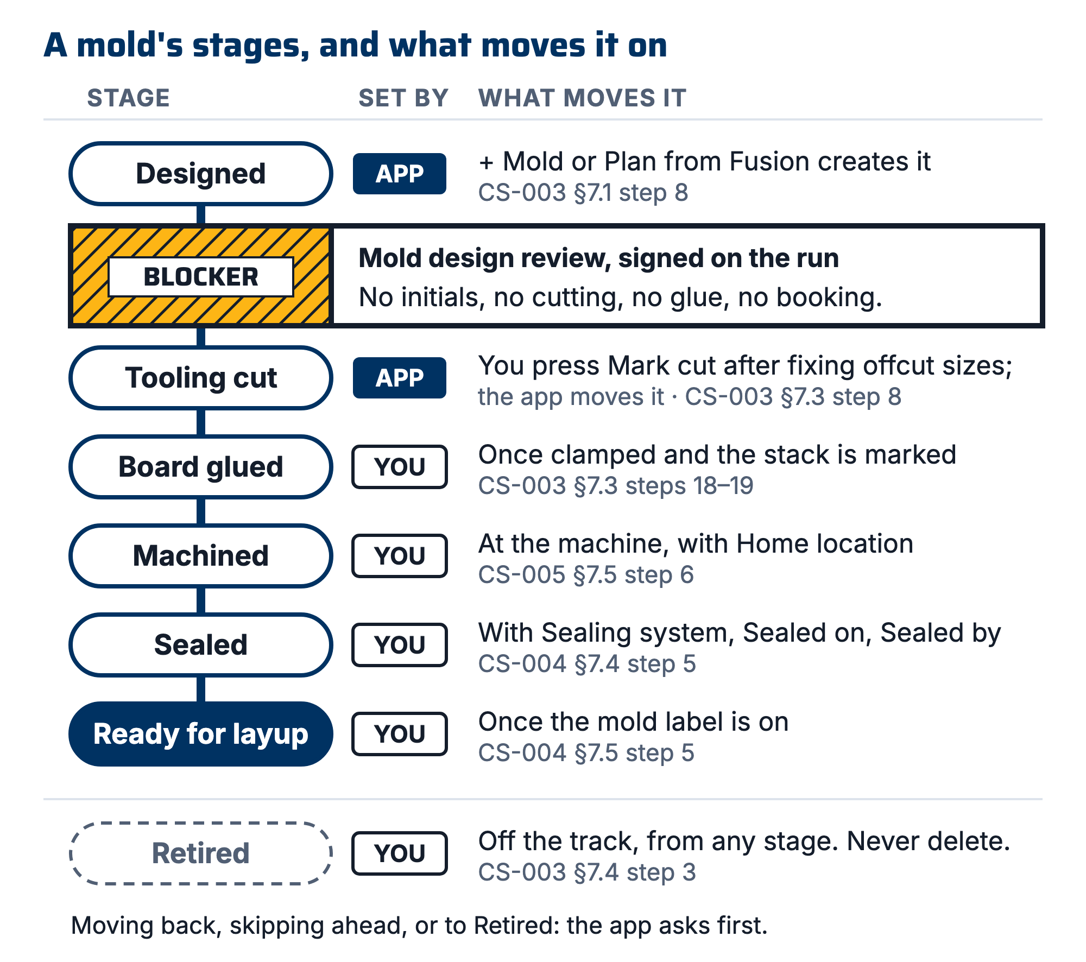
Figure 2. Mold stages on the app's track: Designed, Tooling cut, Board glued, Machined, Sealed, Ready for layup, with Retired off to the side, what moves a mold to each stage, and the Mold design review blocker before any blank is cut.

7.2 Design review: the blocker (PP-03)
- Before any blank is cut from the cut list, any stock is glued or any ShopSabre slot is booked, a reviewer who is not the mold's designer walks this checklist against the CAD and the mold's stack plan (10 minutes):
# | Check
1 | Part surface matches current part CAD revision (open both; overlay)
2 | Flanges ≥75 mm all around
3 | Scribe + datum lines present
4 | No overhangs / negative draft from machining direction
5 | No sections <15 mm; internal fillets ≥ tool radius
6 | Height ≤ machine max-Z (value in CS-005 §5); or splits + alignment features designed; or a split waiver, with the reviewer having checked the deepest machined point and the tool's reach past the collet
7 | Mold file (STK-SN6-###) exists and the Molds overview shows no Short N blanks (stock is recorded in Inventory → Boards)
8 | Machining time estimate written in the work order's Machine mold step note (Glue and machine mold on a wet-layup run); there is no estimate field
9 | Stack frozen per CS-002 §7.2 (mold offsets depend on it)
10 | The plan is the mold's current Mold file, not one marked Superseded
11 | In the Stack drawing on the mold page (under the heading Stack), the dashed mold outline sits inside every block
12 | Every plan warning is fixed in CAD or answered in the Mold design review step note

- Reviewer initials the WO "Mold design review" step. No initials, no cutting, no glue, no booking.
The app holds Mold design review until the CAD is attached or linked on the work order and the signer holds Mold design training, which a lead grants on the People tab (app/workorders.js). A lead can sign without the CAD (Sign without it), and the reason goes in the work order's event log. If the signer is the run's Mold Engineer, the app asks Self-review and lets them press Sign it anyway; it does not refuse. Check that the Mold Engineer field names the mold's actual designer before relying on that warning. The cut list does not check the review at all, so check the run's Mold design review is signed before cutting any blank (§7.3 step 1).
[ PHOTO: reviewer overlaying mold CAD on part CAD, checklist on screen ]

7.3 Cutting blanks and gluing tooling board (Ure-Bond 90)
[held for Simon: which training gluing needs, REGISTER R-003-24]
- Open Molds → Cut list. It offers only molds at Designed whose plan is not Superseded (app/stock.js). Cut only for molds whose Mold design review is signed (§7.2).
- Press Print cut list. Before cutting to a sheet that has been in a drawer, check its batch tag (the four-character tag in the batch stamp) matches the rest of the set (R7).
- Cut each board on a saw (the ShopSabre may be used) along the sheet's numbered cuts, all the way across each time. The cut list allows a 1/8 in kerf per cut (app/packer.js).
- Before each blank leaves the saw, write its mold ID (or the plan name) and its layer tag from the cut sheet (L1, L2b) on it in oil-based paint marker (CS-001 §7.4).
- Press "Mark these boards cut…".
- Untick any board you did not cut.
- Correct every offcut size, in millimetres, to the piece in your hand.
- Press Mark cut. The app moves the mold to Tooling cut.
- Press Print labels on the bar that appears and label each offcut now (CS-001).
- To re-cut a mold, move its stage back to Designed on the mold page (the app asks first). It returns to the cut list.
- Dry-fit boards; mark orientation.
- Place each layer from its layer sheet in the mold's Drawings set: set the insets from the board below, then check the Datum A table. Datum A is the near-left corner of the stack (app/drawings.js). Blanks carry 1 to 2 in of margin past the mold and are rounded to a 1/2 in size (app/slicer.js), so a small shift still machines; the Datum A check catches a board sawn oversize.
- Vacuum the faces, wipe them with IPA, and let the IPA flash off fully before glue touches them (TB: let the solvent fully dry).
- Pre-mix Part B (TB).
- Measure 1A:1B by volume, which is 100A:88B by weight (TB).
- Mix for 3 min, scraping the sides and bottom of the container (TB). Pot life is 8 min at 73 °F (23 °C) (TB), so mix only what one joint takes.
- Spread thin and even on one face, mate, and clamp evenly. 4 h clamp minimum (TB). For stacks >3 boards or very large molds: dowels + spot resin alternative (R2).
- Mark the stack immediately, in oil-based paint marker, 15 mm characters, on two adjacent side faces: the mold ID (MOLD-SN6-###), part name, WO, and the up-direction (CS-001 §7.4). Mark faces the toolpath will remove less than 6 mm from, or mark the bottom.
- Set the mold's stage to Board glued.
- Write the mix time and clamp-off time in the note on the work order's Glue mold stock step and sign it. On a wet-layup run, write them in the note on Glue and machine mold and sign that step after machining (CS-005 §7.5).
- Do not machine until full cure: 16 h at 73 °F (23 °C) after glue-up (TB). The TB also calls the joint machinable at 4 h; that is the datasheet figure, and FEB waits for full cure.
⚠ CAUTION: A Sharpie does not survive here. Between glue-up and the CNC slot a glued block sits on a shelf beside three other glued blocks, gets clamped, weighted and IPA-wiped, and the shop's own isopropyl dissolves a Sharpie mark. This is the highest-confusion and lowest-cost-to-fix moment in the whole mold process.
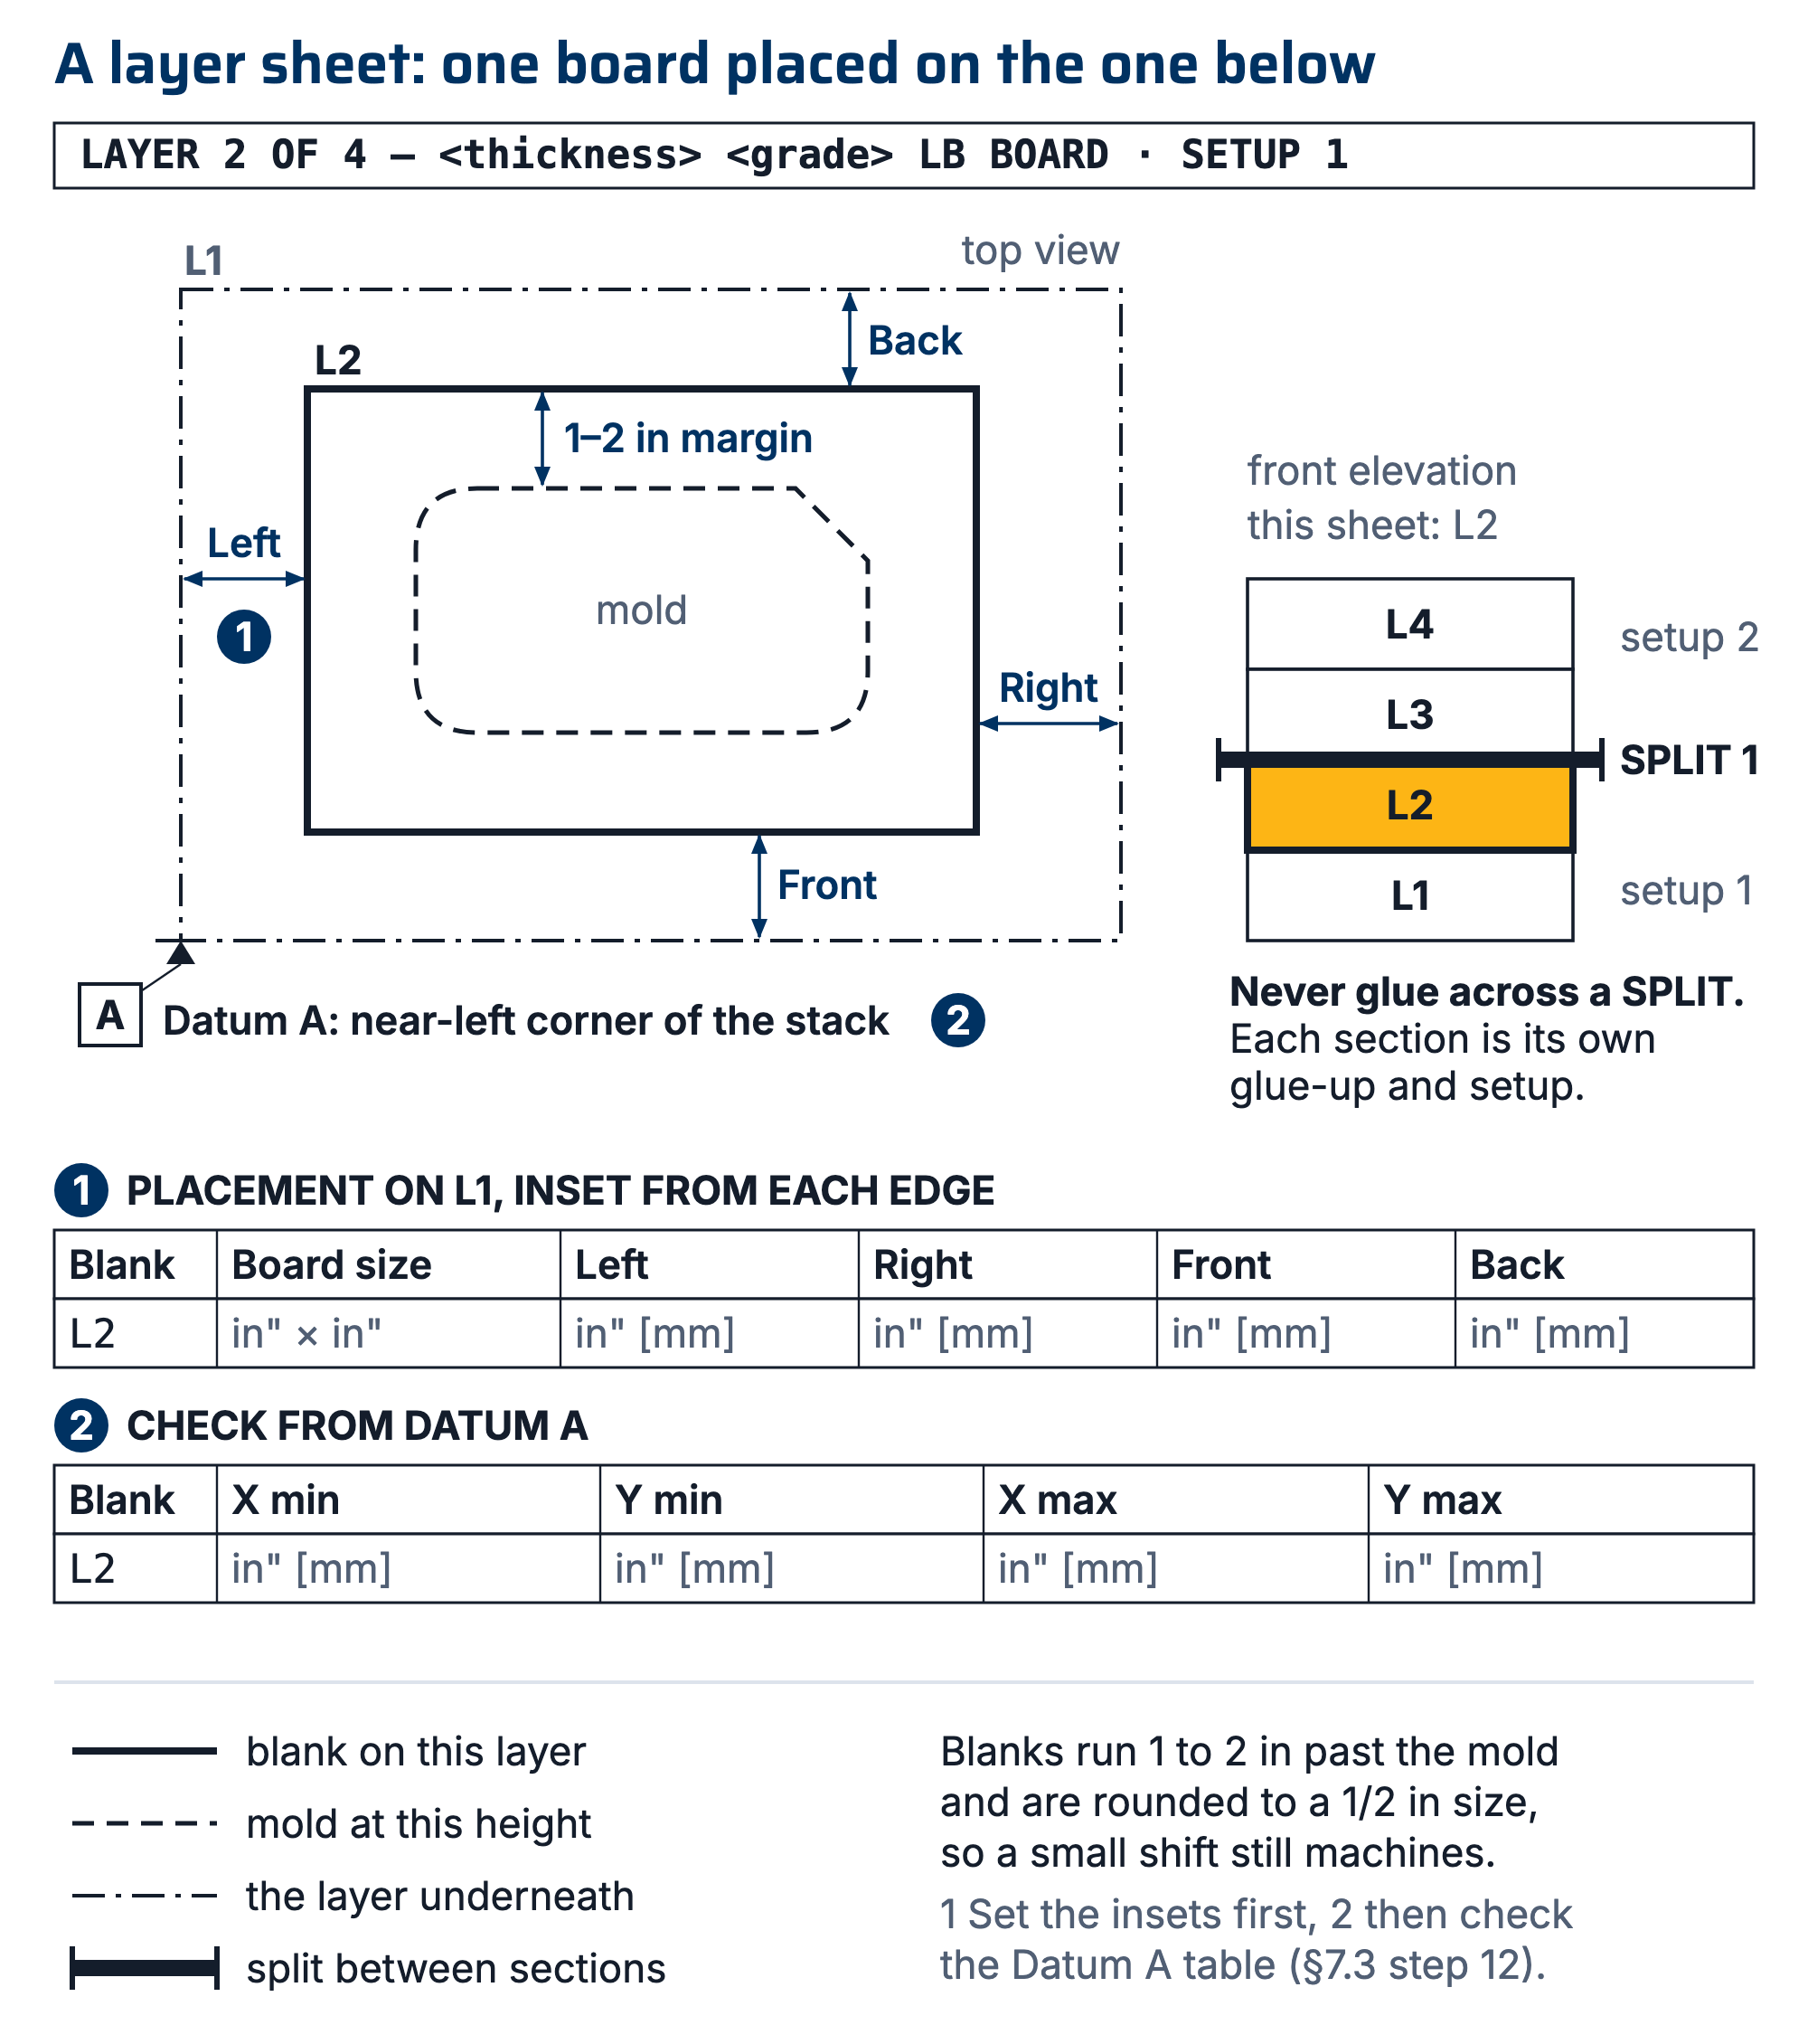
Figure 3. A layer sheet from the mold's Drawings set: each board placed on the board below by its insets, Datum A at the near-left corner, the 1 to 2 in margin on a half-inch lattice, and a SPLIT line between sections.

7.4 Machine, clean, seal
- Machine per CS-005 (zeroing rules live there). CS-005 §7.5 sets the mold's stage to Machined and its Home location.
- Clean and seal per CS-004, which fills the mold record's Sealing system, Sealed on and Sealed by and moves its stage to Sealed, then Ready for layup.
- Retire a mold that will not be used again: set its stage to Retired. Do not delete it.

8. Quality checks / acceptance criteria
Check | Target | Method | Record where
Design review complete | Checklist initialed before any blank is cut | WO blocker step (Mold design review) | WO
Glue lines | No visible gaps; no board shift | Visual after clamping | WO Glue mold stock step note (Glue and machine mold on a wet-layup run)
Machined surface | No steps at section joints > 0.5 mm; scribes crisp | Visual + fingernail | WO qualityChecks
Machining time actual vs estimate | Recorded (feeds future planning, PP-06) | Machine log | WO Machine mold step note

9. Records
The mold record (MOLD-SN6-###) holds the stage, Home location, Board density min and max, Highest density cut, Board layers, Sealing system, Sealed on, Sealed by, Parts pulled, the Mold file (STK-SN6-###) and any Datum cut plans. When reference cuts are taken off a mold after a part comes out, the drawing should be attached to the mold under Datum cut plans.
The work order holds the Mold design review buy-off, the Glue mold stock step note (mix time and clamp-off time) and the Machine mold step note (machining estimate and actual), plus photos at glue-up and after machining. On a wet-layup run the two steps are one, Glue and machine mold.

Appendix A: 3D-printed compression (forged CF) molds
From the SN5 Forged/Compression Molded Carbon Fiber study: PLA/PETG molds (40–50% infill, 4–5 walls, 0.1 mm layers) are free at Jacobs but deform/crack at ~50–100 psi and soften at 60–100 °C, with no hydraulic press and no heated cure. Design: piston-into-cavity, stroke ≈ 2× part depth, 0.1 mm sliding-face offset, chamfered split points for wedging, vent grooves against hydrolock. Clamp math: four 600 lbf trigger clamps ≈ 2,400 lbf spread over the part area → ~150 psi at 4×4 in (16 in²) but only ~37 psi at 8×8 in (64 in²). Read the two limits together: parts must be small (≲24 in² for 100 psi, ≲48 in² for 50 psi) for clamps to even reach the 50–100 psi consolidation target, and at exactly those pressures a printed mold is at its cracking threshold. So for small forged parts, always distribute the load with through-bolts + aluminum backup plates rather than bare trigger clamps (whose pads also relax over time); for anything larger, clamps cannot reach target pressure at all, so redesign, or accept low-pressure quality. First-part failure mode to avoid: resin starvation (see CS-008 mix math).

